Swapping to a 2000 Intake Manifold
In my quest for more torque at low revs and better efficiency my research came across a totally new intake manifold. These were fitted to XJ's, TJ's and ZJ's from mid 1999 to the end of production in 2002. You can use one from any of these models I have been told. These manifolds are good for 15 hp according to a Jeep engineer that had said that they had to come up with a way to bring the power back up after new emission changes cost them 15 hp. ( smaller exhaust ports and twin catalytic converters plus software changes among the changes ). So that is why the newer Jeeps are only rated 3 hp more than before. Of course though if you fit one of these manifolds to a earlier Jeep without the different emission you get a 15 hp boost in theory. Those running strokers even more as JeepSpeed mention a 25 hp gain on there race engines just with this change. But remember that an engine is just a pump and wont flow in any more than it can flow out. The more modifications to the cylinder head, cam and exhaust system, the more benefit you will see.
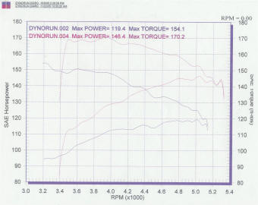
But now years later I have a dyno chart showing a before an after. DJJordache posted a write up here showing that swapping to this along with the Hesco fuel pressure regulator and 99 injectors, as I have also done also, showed 26.9 hp and 19.7 rear wheel torque at the rear wheels comparing on the same dyno before and after the swap. Click on the chart above to see a larger view. Now that is at the rear wheels and we all know of the parasitic loss of the drivetrain with a XJ running at a reported 22% and the ZJ used for the dyno even worse with as high as 30% being mentioned with the auto. So that is quite some gain but can only be achieved with a good set of extractors, exhaust and intake filter flow as was used here. It must be noted that some of this gain would have come just from the injectors especially if the old ones were old and dirty. Also I have seen more dyno charts since and 96+ Jeeps with OBDII systems do not respond as well and have suffered up to 3 mpg fuel loss so would not be worth it unless you have plenty of other modifications as mention before. Also those that have not used the later injectors along with the required higher fuel pressure to run them, did not get as good a results. Basically if you have a 96+ Jeep with few flow modifications, it is not a worth while swap.
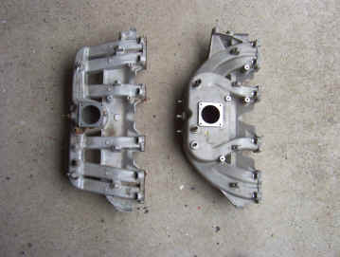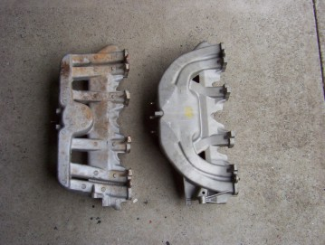
Here you can see my 95 on the left and the completely new intake manifold on the right. The runners are far more curved leading to the ports without the harsh right angled bends that the earlier ones have. You can also see that the plenum chamber which sits right under where the throttle body bolts is much bigger. I bought my intake from USA Driveline in Victoria which also have an office in Queensland but will send anywhere in Australia. They bring in a lot of XJ's from Japan which they strip for parts to sell.
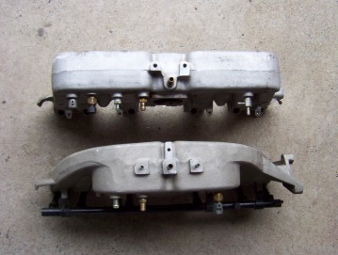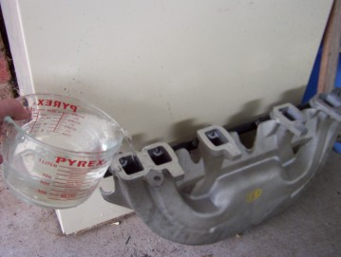
The best way I thought of to show just how much bigger the new intake is was to block off the throttle body by cutting a canvas gasket to mount underneath the throttle body before bolting it down and to block off all the vacuum ports. I then used a measuring jug to fill the intake with water until it reached the top of all the ports. The old one took 2.6 litres or 2600 cc's to fill and the new one an amazing 4.3 litres or 4300 cc's. To think that a throttle body spacer only adds .076 litres or 76 cc's you can see how much bigger in volume this is without the sharp bends in the runners to boot!
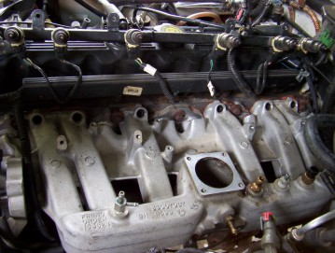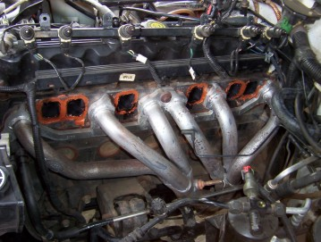
First thing is to pull the airbox out of the way to give you more room to work in. Then strip everything from the intake remembering where the hoses come from. To remove the fuel rail you remove the fuel tank hoses by depressing the white nylon clips each side and sliding it back. Then remove the four bolts holding the rail down and wiggle the rail upwards at each end and along the rail pulling back hard until it pulls free. If you are not changing the injectors this way saves you from worry about leaks from the upper O rings. You can clean up the bottom ones by removing them and soaking them in Diesel for a while and giving them a good rub if they are still in good nick. Otherwise you will have to buy a complete kit to replace upper and lower ones. There are four upper bolts to remove as well and another four underneath. I was able to get the first two underneath at the front of the motor from above but the last two had to be done lying on the ground and used a ratchet ring spanner. I left the extractors in place ( held on by the very first, middle and last bolts ) as they had only been on a year and the gasket was un-damaged when the intake was removed. The RTV Copper silicon just rubbed off with my fingers.
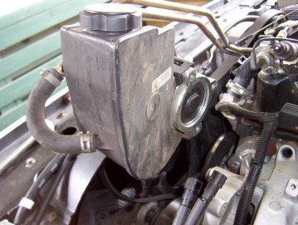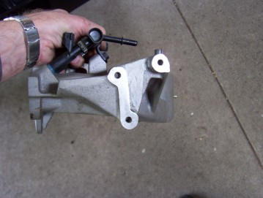
Now this is where it can vary between models but the Australian ones are like mine. The LHD ones are easier as don't have the fan mount below the steering pump like shown so only need the same pump bracket that the intake is off. In the US models before '97 I believe do not have the power steering pump mounted to the front of the intake so you would need to buy one of these and it's bracket. My pump was attached to the fan mount but the newer ones attach to the intake itself like shown above.
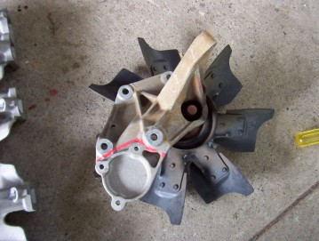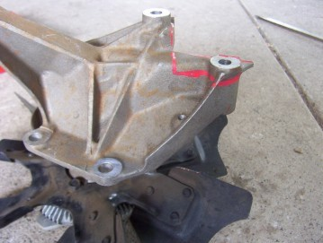
So I had to remove the pump part shown in red from the fan mount ( RHD models only ) so that it would not interfere with the pump bolting to the intake instead. I left as much as possible of the original fan mount to give it strength. When I compared it to a Wrangler set up with the late model intake this looked stronger than the stock setup. I still left part of the upper bolt boss in place for additional stiffness even though you can not use it. You must however remove some off the back of it as it hits the intake otherwise as shown in the right picture. I have since removed more as I since fitted an electric 16" fan ( must pull around 2000 cubic feet ) into the original shroud.
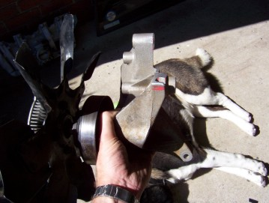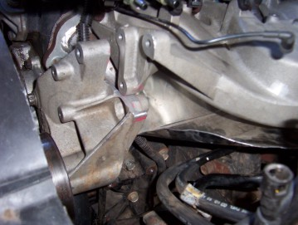
Shown above is the fan mount with the back of the upper boss or bolt mount removed to clear the intake for the RHD's. You can see in the right picture how it clears the pump mount on the intake. I found out later I might have been able to remove slightly less thickness from the upper bolt mount due to the pump spacing covered next. Even so there has been no flex at all in the fan mount the way I have done it. You will find it easier to swap the fuel rails ( and injectors if necessary, see below ) before hand as I could not use the new one that came with the intake as it did not have the return line fitting for the fuel. Make sure you jot down the wire colours for each injector first as it would be possible to swap a pair around and you don't want to do that! The new intake was put back in place using a light smearing on RTV making sure that would not ooze into the ports affecting the airflow when tensioned up. Start tighten the bolts in the centre and work yourself in a cross hatch pattern towards the outside. Then go back over them all again the same way to make sure it is evenly tensioned.
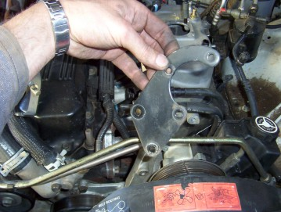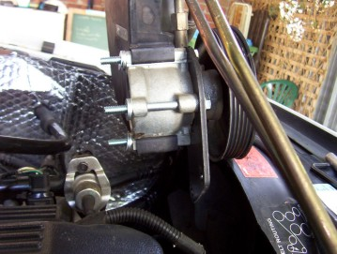
This is the front mount for the pump that was on the old one and it will still bolt back in place using the same two threaded bosses on the fan mount as well as the three bolts on the pump. This supports the front of the pump as well as becomes the upper mount for the fan mount as well. This same bracket was also used on the later model installs. What I did found after I started the engine for the first time was that the belt did not run exactly on the same part of the fan pulley below. To make it do so I had to space the pump forward 3 mm with spacers as shown in the right picture. It then ran perfectly in the same spot after that and everything lined up. I can only think the later models run a slightly wider pump at 60 mm thickness compared to my 57 mm one. I also noticed at this point that the threads in the intake for the pump bolts were different. The old bolts were 5/16" UNF but the new ones are 5/16"UNC and 3 1/2" long. Buy them first so you don't have to run out and buy them in the middle of putting it all back together.
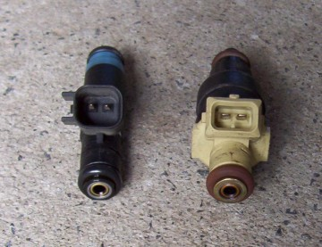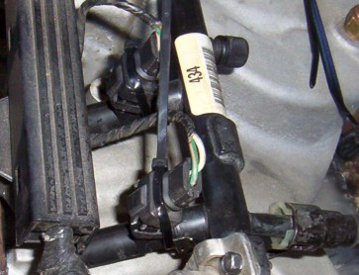
Now I scored with my intake that I bought a full set of injectors that looked like they had only done a few kms before being written off. It seemed a shame not to use them as mine had done over 110,000 kms and even though I run premium now a days and fuel injector cleaner every 5,000, they still showed a little build up. The newer ones also are completely different in construction and weighing probably only a third of the old ones. This could also mean quicker response to the electrical pulses as you always hope things get better with development! The only problem was that the old plugs do not fit onto the new injectors as the mount differently. To get around this I ground down the two tags you can see on the left new one in the picture until the overall width was the same as the old one ( 17 mm ). This then allowed the old plug the slide over the new injector but nothing to hold it there. So as you can see in the right picture I just used a nylon tie to hold them in place. Make sure the plugs still face the same way as before with the curved cut out section facing the fuel rail and that you push them all the way down engaging the pins fully. I found that when I first started that one had not seated completely so ran rough until I found which one it was and pushed it home and tighten the tie and no problems since. Remember also that if you have a pre 96 with the fuel regulator on the fuel rail, it will be only running at 39 psi instead of the later pressure level that the injectors are designed for at 49 psi. So you can add a adjustable regulatorlike I show here or, Coas from Jeep Cherokee Forum says, there are fuel regulators that fit Jeep fuel rail with no modifications. Chrysler #4418850 or 5277829 or 5277864. These regulators will bump the pressure up to 40 idle 48PSI at WOT.
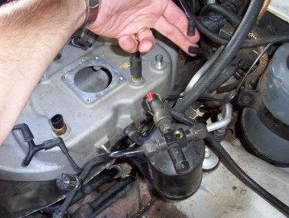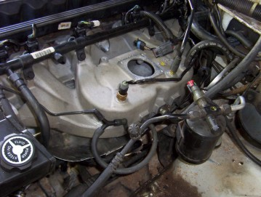
Time to hook up the vacuum hoses and sensor. The big hose to the brake booster fitted no problem as was the same size and in the same spot. The hose to the rocker cover ( pcv valve ) fitted straight in as I had earlier already changed it to the later model one which is bigger in diameter and better in controlling blow by. If you have not done this you will have to adapt the smaller hose. The two hoses in my fingers have to be extended and re-sized to fit the ports. One is from the map sensor and the other is from the cruise control and vacuum tank in the bumper. The hoses from the fuel regulator and the charcoal canister used to share a port but with the pressed in ones of the new intake you cannot swap it over. So I used a Y joiner as shown to connect them to the intake. Also had to extend the wires for the MAT sensor ( manifold intake temperature ) ( some call it a IAT intake air temperature ) as they did not reach. Some people fit this sensor into the intake hose from the airbox to make the engine run a bit richer giving you more power as written about by Dino Savva here. This would then free up a port saving you the Y joiner but with theintake shield that I have it would make little difference in my case so left it stock.
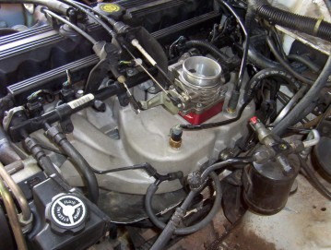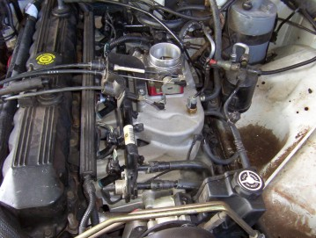
Then it was just a matter of clipping on the fuel lines and drilling a single hole for the fuel line support bracket instead of the previous two. Then bolting down the throttle body and even re-used the spacer again for that extra 76 cc's! The intake also came with a late model throttle body but the plugs do not match and I had already bored mine as well. Replace the cables and refit the airbox and you are done.
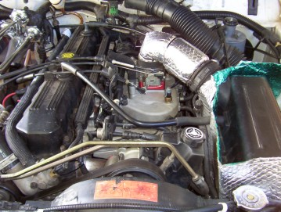
Now for the road test. I found the off idle response all the way to around the 2500 rpm mark to be the most different. If you just are travelling around town on flat roads there is not much of a change but as soon as I hit the hills I use every week it really showed. The steeper the hills for more it just pulled stronger than before and found I had to feed less throttle in than before to keep speed on the hill. This is was what I expected as longer runners perform much better at producing torque at low revs than short straight ones do which work better at high revs. You will even find some cars have two sets of runners with a solenoid switching to long runners for low revs and to the short ones for high revs. As I spend most of my time around the 2000 revs this intake is perfect for me and especially for all the towing I do in deep sand etc it will be even better. My trip computer is also showing around 7% better. You must reset the computer and to do this just disconnect the battery and then turn the key to start and hold for at least 30 seconds to remove any stored power in the computer. It is then important to do 'average' driving for the next day or so to get the right parameters set. If you just cruise or drive hard then the parameters will be set too low or high and might not be able to adjust enough for other conditions! Don't be surprised if the idle is a bit rough while the computer resets itself and sometimes even a day or two later depending on your mileage. I found also that by pulling the fuse marked for the engine control unit ( second from the right under the hood ) and leaving it out for a few hours cleared a code I had so might reset the ECU as well. You just cant drain the power stored in it unless left it out for a long time out like over night but at least saves you resetting all your radio programs etc.
I am happy with the result and it met my expectations. Don't do this it you are the type that revs it hard everywhere as you can lose response up high in the rev band or if you are expecting a large change. It is not that sort of change. A great by product that I did not expect was that my wife noticed straight away that the exhaust sounded deeper and more throaty! Just read since that it was a claim made by Jeep as well for the late models with a change in the intake and exhaust mentioned to give that sound! I have since also done 6000 kms trip in 100*F temps towing my trailer over beaches and one track alone had over 300 sand dunes and the new intake manifold made it that much easier than before.

[Index]

